Phys 170 Lecture Notes
Christopher Kalitin

Jan 6 Lecture
Mechanics is the science of bodies under forces and the special case of at rest. Dynamics and Statics.

Idealizations: point particle, rigidbody (doesn’t deform!), concentrated force, etc, massless pulleys with no friction.

1st law: Stay constant unless acted on by an external force
2nd law: F=ma
3rd law: All forces appear in pairs

Basic (independent) units: length, time, mass, etc.
Derived units: force, acceleration (second derivative of displacement), etc.

Notice that to get the derived units you require the basic units. Eg. displacement is required to get acceleration. You can reverse them too, make force the basic unit and derive mass.

Newtons are mass times acceleration. Kg * m/s²

In SI, Newtons are derived, while in FPS, mass is derived (slugs, lb*s² / ft)

Always carry 4 or more sig figs in calculations, then in the end show 3.

Always use engineering notations, giga, mega, micro, nano, etc.

“Round to even digit rule”

Jan 8 Lecture
Vector variables are either bolded in text, or with an arrow on top when on paper.

For vectors:
“Magnitude” = “Absolute Value”

R is a vector, R is the magnitude.

Cartesians: Rene Descartes
Coordinate system with perpendicular axes

j = positive y, i = positive x. These are unit vectors or basis vectors

Cartesian components and x and y, i and j.

Coplanar vectors lie in the same plane. Ie. all that we work with.

Cartesians are defined by magnitude and direction angle from a basis vector, or cartesian components/coordinates.

Calculators always give you answers in the rightmost quadrants. 90 degrees to -90 degrees.

Jan 13 Lecture
We use u_{a} to specify the unit vector of vector A. Eg. A = A*u_{a}

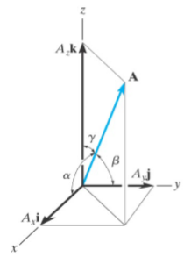

We can express the vector A as the angle from the 3 basis vectors.

We then express this with cos:

We can be more professional and express vector A in terms of the unit vectors:
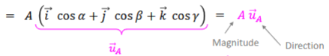

We can also find this nice relation:

You project vectors onto planes! Eg. If you want to find F_{y}, first take the Z component and project that (using cos or sine, probably cos) onto the x-y plane, then solve for whatever direction you want.

Be careful with signs! If your projection gets you on the negative side of an axis, you need to put a negative! This is important and cos/sin functions don’t do it for you.

x, y, z, = i, j, k

When finding the resultant force, report it as a vector, no as a magnitude.

If you have 3 unknowns, you need 3 equations.

Jan 17 Lecture
Dot product formula:
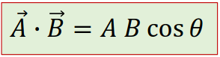

Dot products between different unit vectors are zero. All perpendicular to each other.

Cos: if 0 > theta > 90, then ABcos(theta) is positive, otherwise it is negative.

Acos = arccos

Because i * i = 1 and i * j = 0 (since these vectors are perpendicular), we can write A * B = (A_{x}i + A_{y}j + A_{z}k) * (B_{x}i + B_{y}j + B_{z}k), now multiply this out and notice that all terms that aren’t in the same direction disappear, and we get a proof that A * B = A_{x}B_{x} + A_{y}B_{y} + A_{z}B_{z}.

To convert a vector into its unit vector, divide by magnitude.

Jan 19 - Mastering Engineering HW1
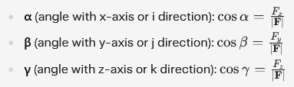
Use these formulas to find the angles with the coordinate axis. It’s actually very simple, it’s just taking the arc cosine of the x component over the hypotenuse. It’s simple, just find the angle, easy to picture too.

Goddamn I think we’re finally getting into Euler angles! Not quite, but closer!
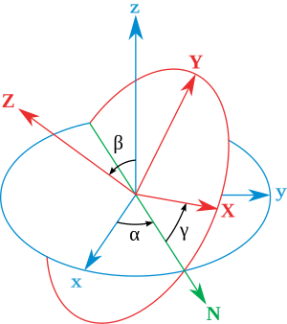

Jan 20 Lecture
Remember that tension is the same on all points on a rope.

Particles only have translations, no moments or rotation.

On FBDs, don’t include forces the object exerts on the environment. Only environment on object.

Include gravity at the end if the object has mass.

Only include direct forces, not indirect. Imagine an array of cubes, Newton’s cradle.

Label & name all forces. Simple stuff.

Lengths of all similar vectors on all FBDs in a system should match. Newton’s third law.

Newton's third law pairs are expressed as F_{2on1} and F_{1on2}.

When writing out the vector sum of all forces, use + for all terms. Only on components do you use signs.

If a force is unknown, just draw a random line for it.

If you guessed wrong, you don’t need to redraw the vector, you just need to write down that the force is pointing in a different direction than the vector shown. This applies to 158 too, like the horrible resistor grid questions.

Write: “Direction is opposite to what is shown.”

FBDs are up to a quarter of your mark. Don’t make mistakes, put effort into it. 5 minutes. Double check. Really big! Half a page, label everything.

Jan 24 Lecture
Moment of a force = amount of rotation caused by a force

Depends on force magnitude, and moment arm of the force, ie. distance from origin point (eg. hinge), and angle between force and moment arm.

Two definitions of torque, scalar and vector.
M₀ = ±Fd

Moment arm: minimum perpendicular distance between origin and line of action of force.
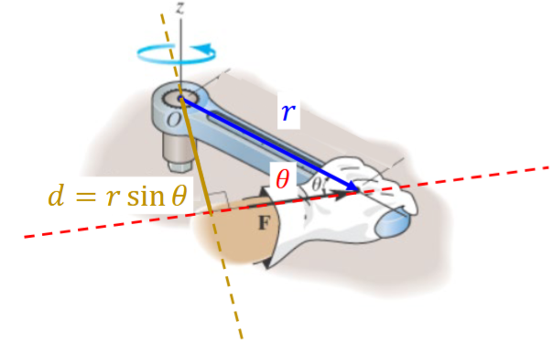

Now, if you know the angle between the object and line of action of the force, you can solve for d:

M_{o} = ±Fr*sin(𝜽)

With torques, the force is a sliding vector, if you change its position along the line of action of the force, the moment arm does not change.

Clockwise = negative rotation

Vector method:
Magnitude calculation is the same: M_{o} = ±Fr*sin(𝜽)

Goddamn Litinskaya is great.

The r vector connects the pivot point to any point on the line of action of the force.

Cross product visualization:
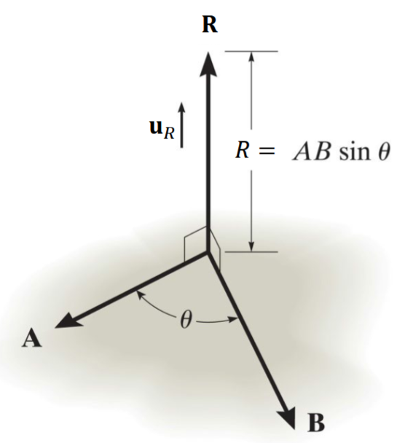

Visualize how R is perpendicular to both A and B.

Cross products are not commutative:
Imagine the right hand rule for cross products! Your palm is in the other direction if you flip the vectors!
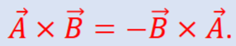

They also follow arithmetic rules (multiplication by a scalar and distributive respectively):
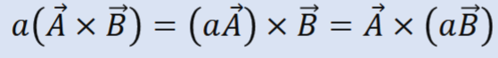
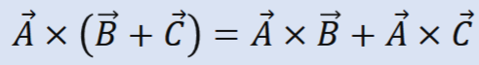

A x B = ABsin(𝜽)

Cross Product is a 3D determinant!
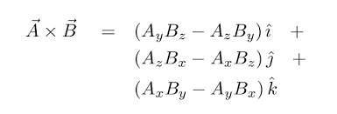

Always set up a 3x3 determinant to get full marks, the more work you show the more partial marks you can get. Also show transformations.

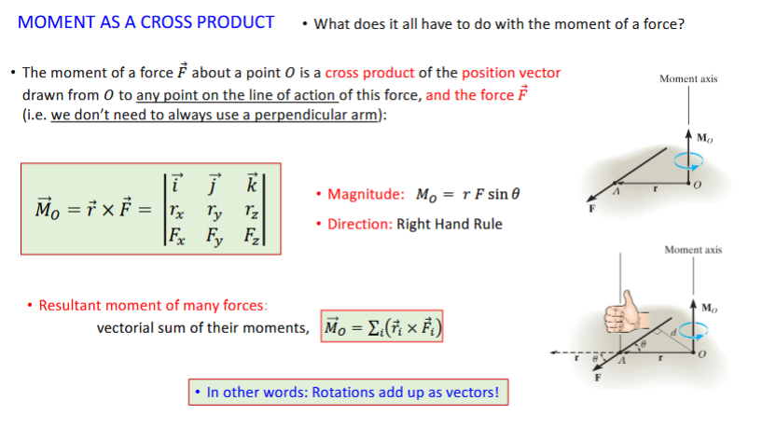

Jan 26 - Mastering Engineering HW2
Solve using this equation where the division is the A variable.
${{\hat{F}}_{1}}_{}={F_{1}(\frac{{\hat{r}}_{1}}{r_{1}})}_{}$

Jan 31 Lecture
Remember cross products are not commutative.

Always used 3 significant figures, pad with zeros.

“During this lecture and in our future lives we’ll be interested in [physics].”

Moment couples are free vectors, you can move the origins.

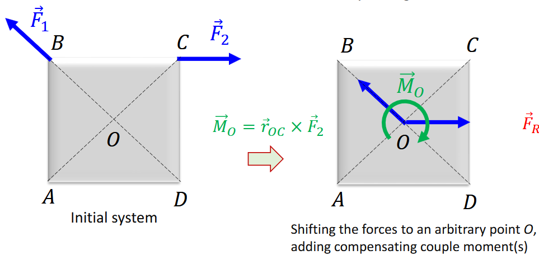
You can simplify forces by putting them around the origin and adding a moment vector.

If all forces are coplanar, you can reduce the system to just one force vector (and one momentum vector?).

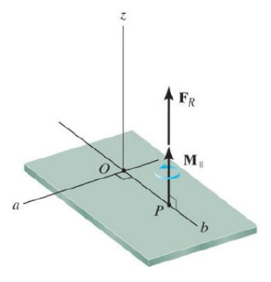
In the general case, you can still reduce the system, but you have to set your origin to the point where the force vector is parallel to the momentum vector. There always exists this point.

We use “wrench” to signify the vector where the force vector and moment vector act in the same direction. It’s intuitive.

Feb 3 Lecture
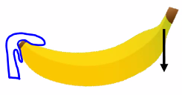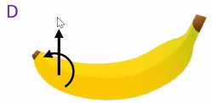
In this case you need both a moment and a force to offset peeling the banana from the top. Since the force of peeling gives both a moment and a force.

Active forces are applied by some external agent. Includes gravity.
Reactive forces support your system.
Internal forces act between different parts of the system.

You need to consider both the forces and moments from active forces, and the equal and opposite counterparts with reactive forces.

Reaction moments are free vectors and always couple moments.

Reaction couple moments develop when it is prevented.

Rigidbody approximation: no bending, no deformations.

TAs refer to this slide when marking:
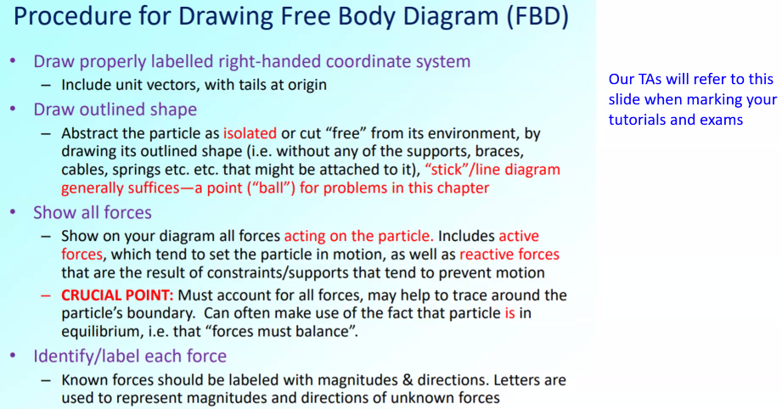

Feb 10 Lecture
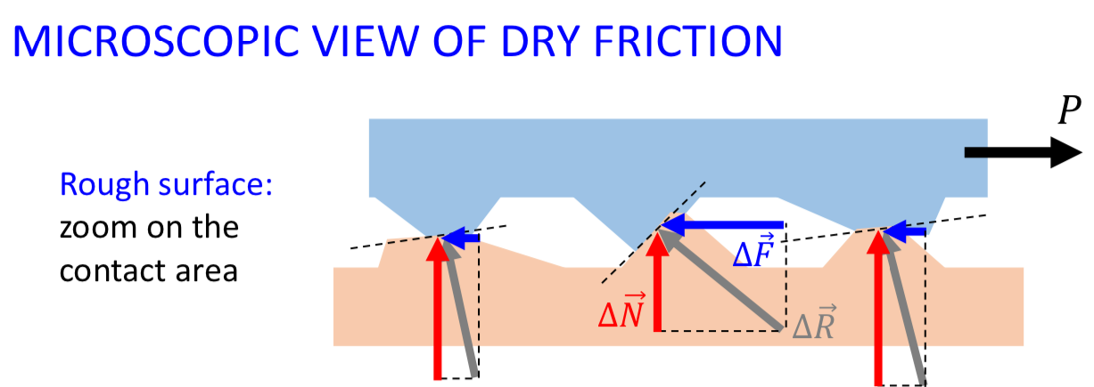
Normal force and friction force are exactly the same thing, just different components of the force acting from the ground into the object.

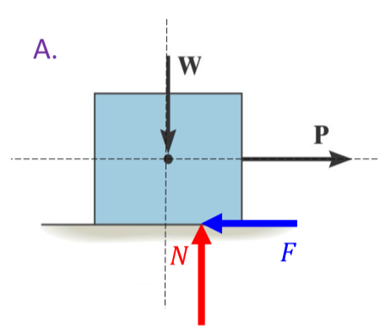
Note the position or the normal force. The box is in equilibrium, so it must not be translating or rotating. The location of the normal force gives a ccw rotation, the pulling force gives a cw moment. You get equilibrium.

Imagine if P becomes greater in magnitude. N goes further right until the box tips, as is expected.

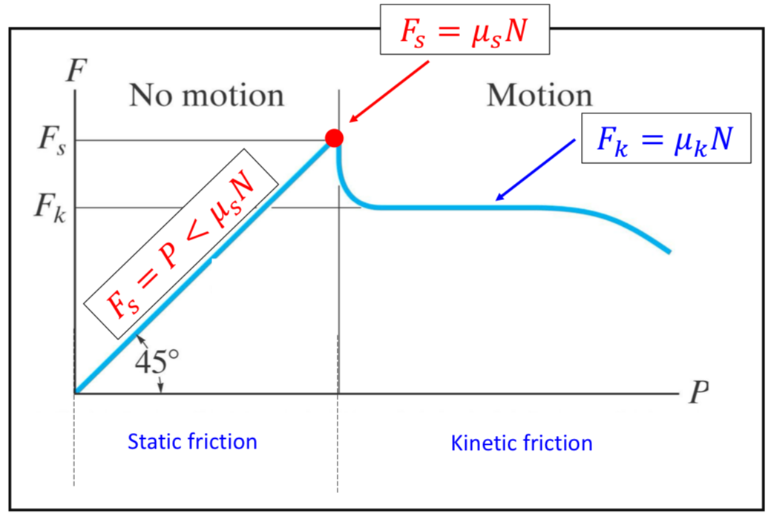

With kinetic friction, you ride over the bumps in the surface.

There are some exceptions where the coefficient of kinetic friction is lower than static friction.

It’s all microscopic forces.

You can break equilibrium by slipping or tipping.

Impending motion equations are when friction force equals translational force or when moment equals moment. Beyond this point, you break equilibrium.

Feb 12 Lecture
If you have more unknown variables than equations, you can turn one of them into an impending motion equation. Now 6 vs 6.

Feb 14 Lecture
Scenarios are determined by your restricted, friction and moments. Compute restrictions (with different variables for each case obv), then check cases. The output moment is computed from your matrix of equations.

Feb 24 Lecture
Kinematics = how but not why objects move

Rectilinear motion = one dimensional
Curvilinear = 2D/3D motion

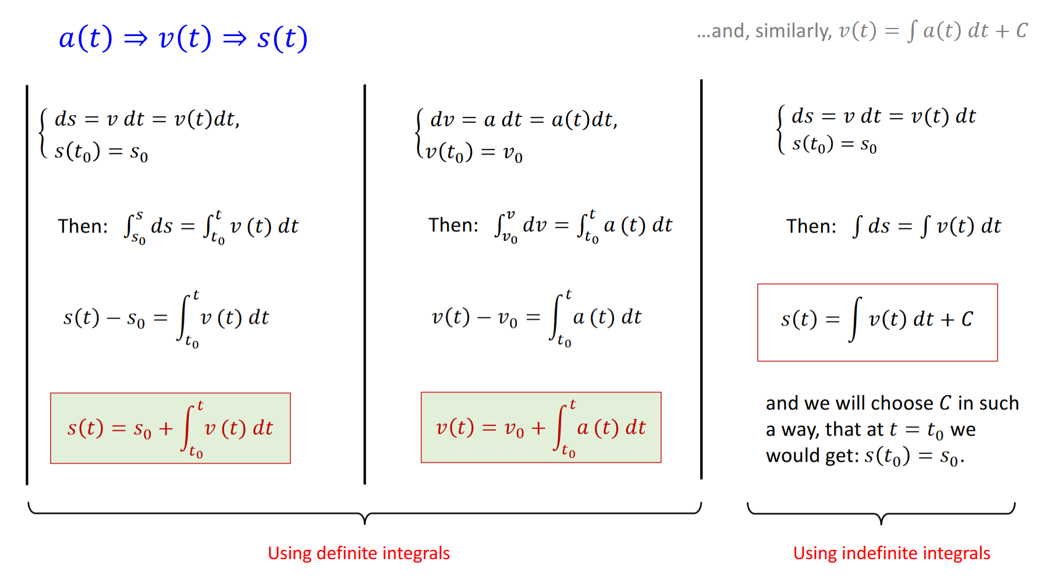
Use ds as change in displacement for each time step.

We use this notation for derivatives:
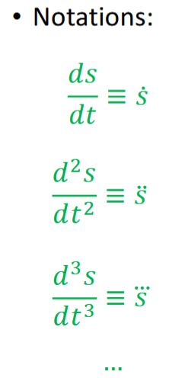

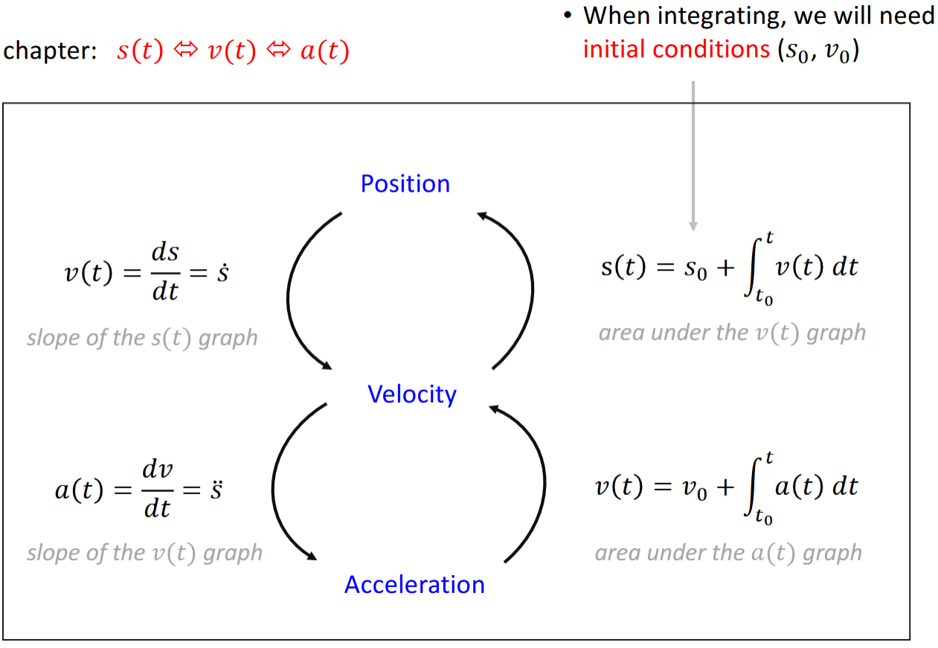

Integration depends on pre-history. Condition at any given point really.

Remember the fundamental kinematics equations only apply when acceleration is constant.

Mar 3 Lecture

Cartesian coordinate system, and normal-tangential coordinate system.

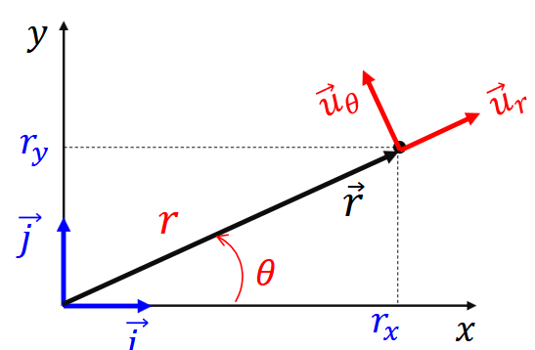

Polar coordinates are also a portable coordinate system, notice how the red coordinate system shifts.

From the diagram above, we can find these relations:
They’re really all completely simple, just components
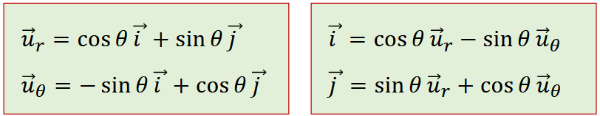
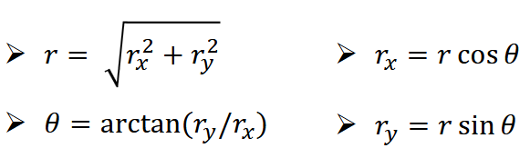

Remember the dot notation represents the derivative:
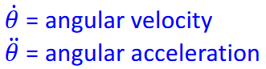

df/dx = f* <- f dot

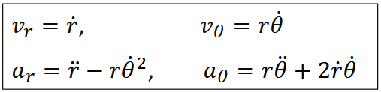

You need to know r dot or double dot and theta dot or double dot. Angular velocity and angular acceleration. From this, you can find the components of v and a.

Cylindrical coordinates have a polar component, and stationary z component. Hybrid of both systems. You use the k unit vector, while everything is in terms of theta and r.

Mar 17 Lecture

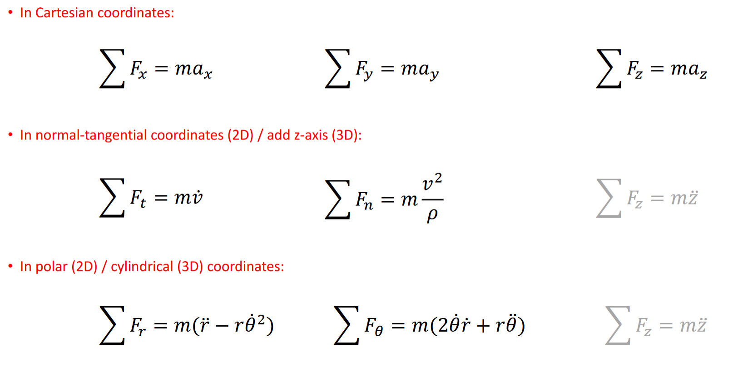

Notice the difference between normal-tangential and polar coordinates.

This is normal-tangential motion (Curvilinear motion). It’s meant for when the velocity vector is the same as the tangent of the path (is this just all the time for everything?).
